February 25, 2019

Professor Meg Daly
Chair, Arts and Sciences Curriculum Committee

Re: Approval of Revisions for MA in Arts Policy and Administration (APA)

Dear Meg,

The Arts & Humanities Panel 1 of the ASCC approved a proposed revision to the MA in Arts Policy and Administration (APA) from the Department of Arts Administration, Education & Policy (AAEP). On Tuesday, February 19, the Arts and Humanities 1 Panel of the ASC Curriculum Committee reviewed the MA in APA proposal by e-vote.

The Department of Arts Administration, Education and Policy (AAEP) embarked on curricular review of the graduate programming in consultation with AAEP faculty and the John Glenn College (JGC). Additional feedback was provided by a department ad hoc curriculum committee, recommendations by external program reviewers, benchmarking similar degree programs, and a student survey. The changes to the MA in APA reduce the total number of credit hours from 49-51 to 43-47, which is more in line with other programs. Other changes include adding more options for student choice within the plan of study, the removal of ARTEDU 5673 Barnett Symposium course, and an increase in Research hours from 3 credit hours to 7 credits hours, which is in line with the John Glenn College’s (JGC) suggested course sequences. AAEP plans to implement these changes for Autumn 2019.

The panel agreed that the proposed AAEP MA APA revisions aligned with the department’s efforts to integrate curriculum with the John Glenn College (JGC) and increase student choice within the program plan. The program revisions were unanimously approved with a few additional recommendations. We now advance the proposal to the Arts and Sciences Curriculum Committee with a motion to approve.

Best,
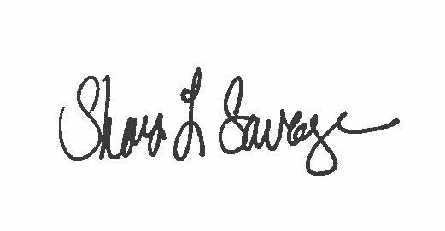

Shari L. Savage, PhD
Associate Professor
Chair, Arts & Humanities Panel 1
savage.12@osu.edu

